Specifications
- Quantities
- 99 Anchor bolts 3/4” Type A
- 53 Anchor Bolts 1 1/4" Type B
- Details
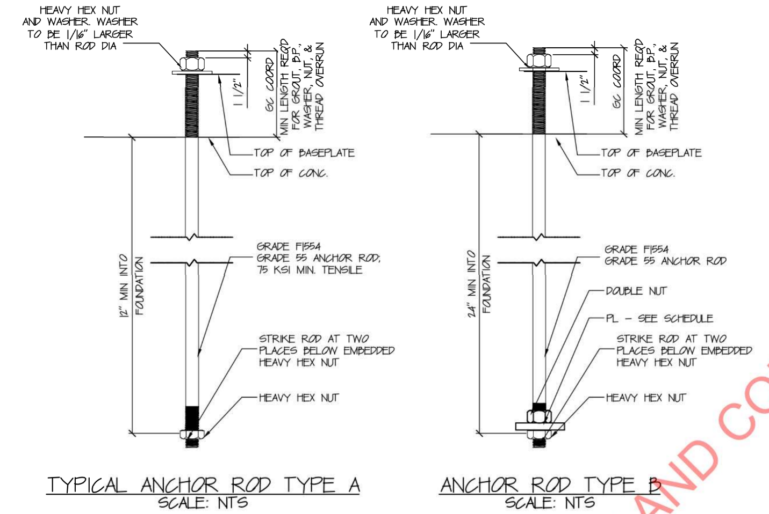

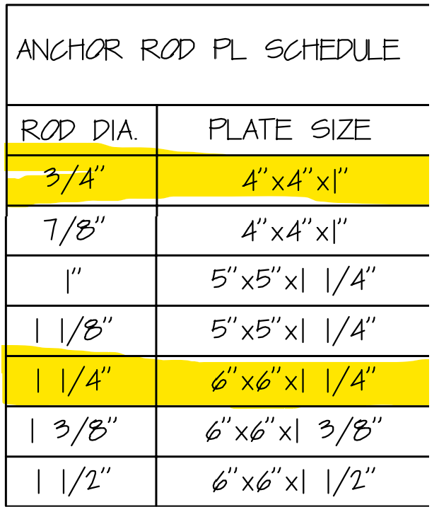
- Plates dimensions ( 3/4” and 1 1/4")

