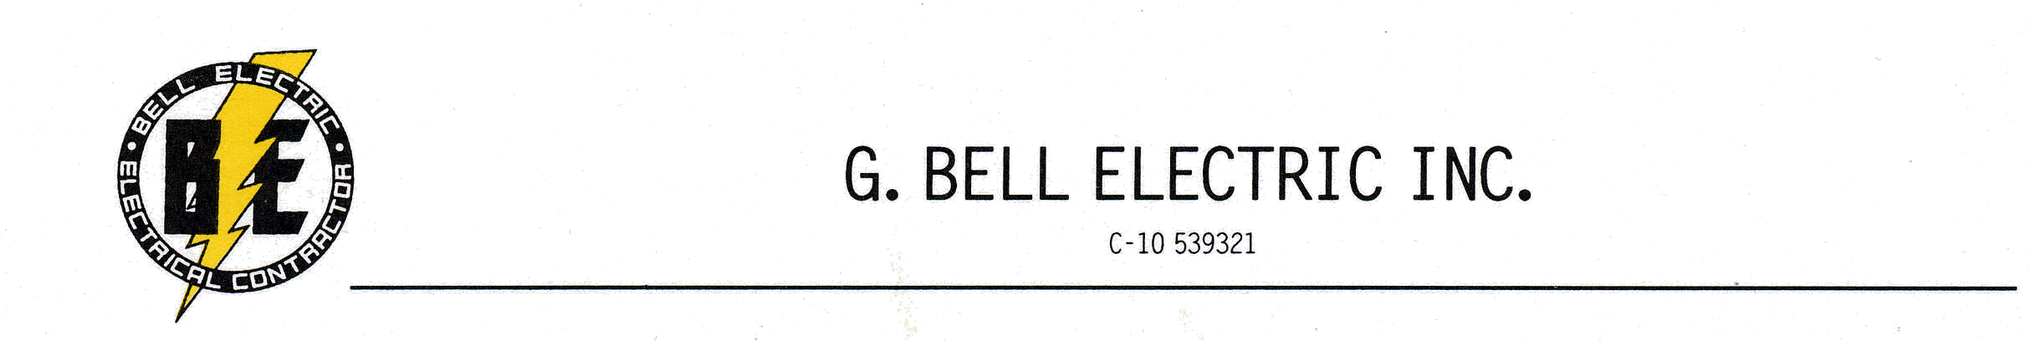

Niagara Bottling Baytown TX
 | PCS
5/8-11 x 120 Zinc All Thread | 426
5/8-11 Zinc Hex Nuts | 1800
5/8-11 Zinc Washers | 1800
5/8-11 Zinc Lock Nuts | 900
2x2x1/4 -5/8 Clearance hole Zinc Square Washer | 900
Greg Bell
G Bell Electric Inc
Dripping Springs TX
greg@gbellelectric.com
Cell 714-936-3395
Office 714-934-8570

