Item# 21: Pin-Spring .500x3.50 material: stainless steel (80pcs)

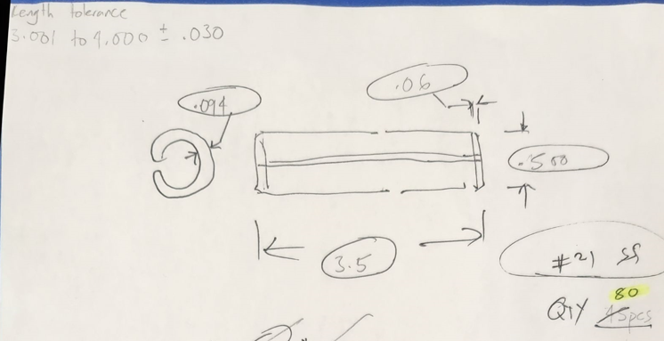

Item# 25: Screw-Soc HD .750x1.50 material: B7 (30pcs)

THDS per Inch: 10

Type of thread:

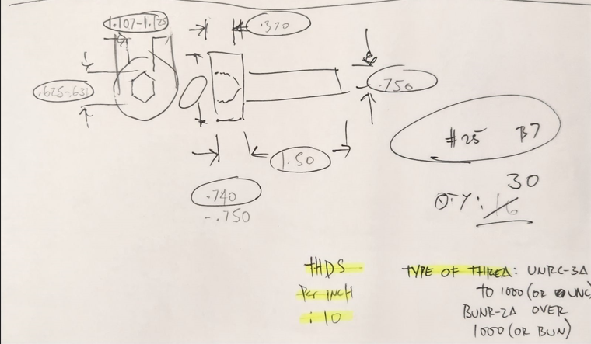

Item# 28: Screw Soc HD 1.50x.375 material: B16 (20pcs)

THDS per Inch: 8

Type of thread: UNC-2A to 1in INCL 8UN-2A over 1 in.

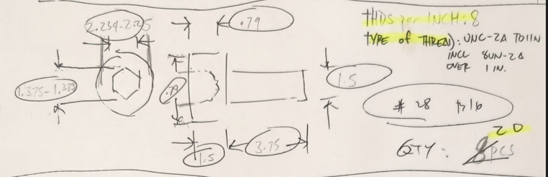

Item# 33 Screw Soc HD 2.00x12.25 material: B16 (10pcs)

THDS per Inch: 8

Type of thread: UNC-2A to 1in INCL 8UN-2A over 1 in.

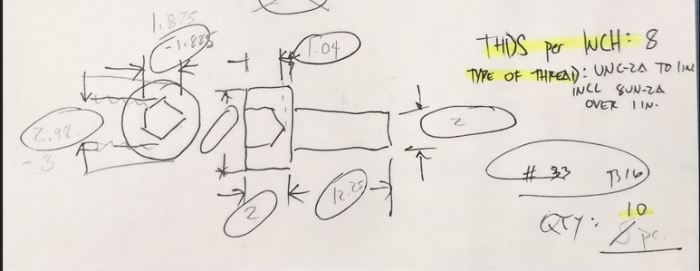

Item# 37: Bolt HEX HD .625x2.00 material: B16 (200)

THDS per Inch:18

Type of thread: UNF-2A

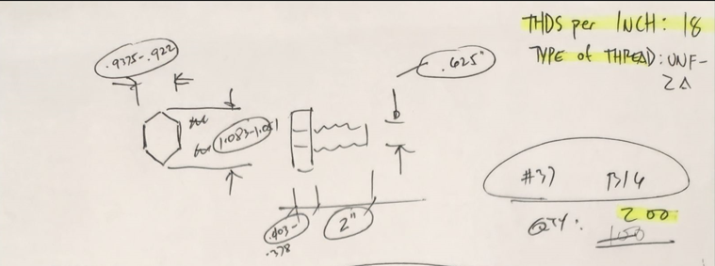

Item# 26: Bolt Hex HD 1.25x3.50 material: B7 (40pcs)

THDS per Inch: 8

Type of thread: 8UN-2A

