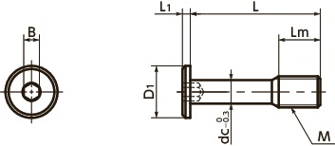

|  |  |  |  |  |  |  |  |  |  |  |
| --- | --- | --- | --- | --- | --- | --- | --- | --- | --- | --- |
| M(coarse) Nominal of Thread | Pitch | L | Lm | D1 | L1 | B | dc | Mass (g) | Strength Class | Material / Finish |
| M3 | 0.5 | 8 | 4 | 6 | 1.3 | 1.5 | 2.2 | 0.53 | A2-40 | Passivated Stainless Steel |