HEX BOLTS M12 ASTM 10.9 OR ASTM A320 GRADE L7  x   1-1/2” W/NUTS     QTY 10

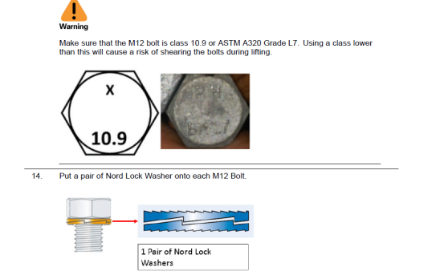

BOLTS M8 X 20 316SS ISO 7380   QTY 10

